

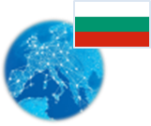 **Bulgaria** *Energy Union factsheet[1]*

1. **Macro-economic implications of energy activities**

Energy and transport are key sectors for the overall functioning of the economy as they provide an important input and service to the other sectors. Together, the activity in these two sectors[2] accounted for 10.3% of the total value added of Bulgaria in 2015. Similarly, their share in total employment[3] was 6.5% in 2015, of which 5.6% in the transport sector and 0.9% in the energy sector.

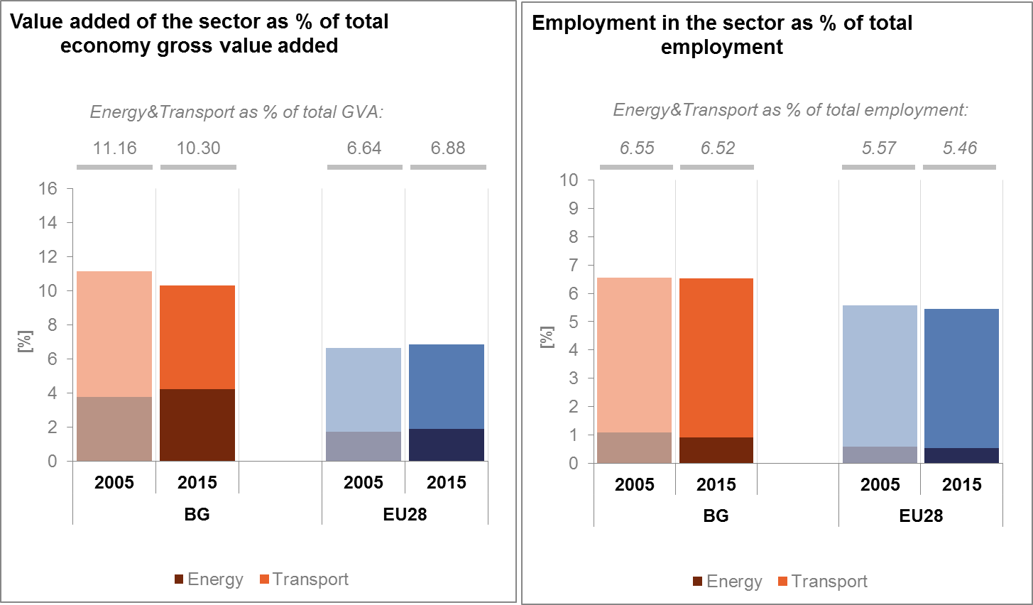

*(source: Eurostat)*

The decarbonisation of the energy and transport sectors will require significant investments and economic activity beyond the remit of these sectors themselves. The energy transition implies a structural shift in economic activity. Energy-related investment and jobs will in part migrate from traditional fossil fuel based activities towards construction, equipment manufacturing and other services related to the deployment of low carbon and clean energy technologies. At the moment, the efforts related to the low-carbon and clean energy transition in sectors beyond energy can only be partially quantified and are therefore not included in this analysis.

In the case of renewable energy sector, both the direct as well as the indirect effects on employment are being estimated. According to EurObserv'ER, in 2015, the share of renewable energy related employment in total employment of the economy in Bulgaria was about 0.25%. The turnover of the renewable energy industry in the same year was estimated at around EUR 0.68 billion, about three quarters being attributed to the biomass (50% of total renewable turnover) and to the heat pumps (25.7%) industries.

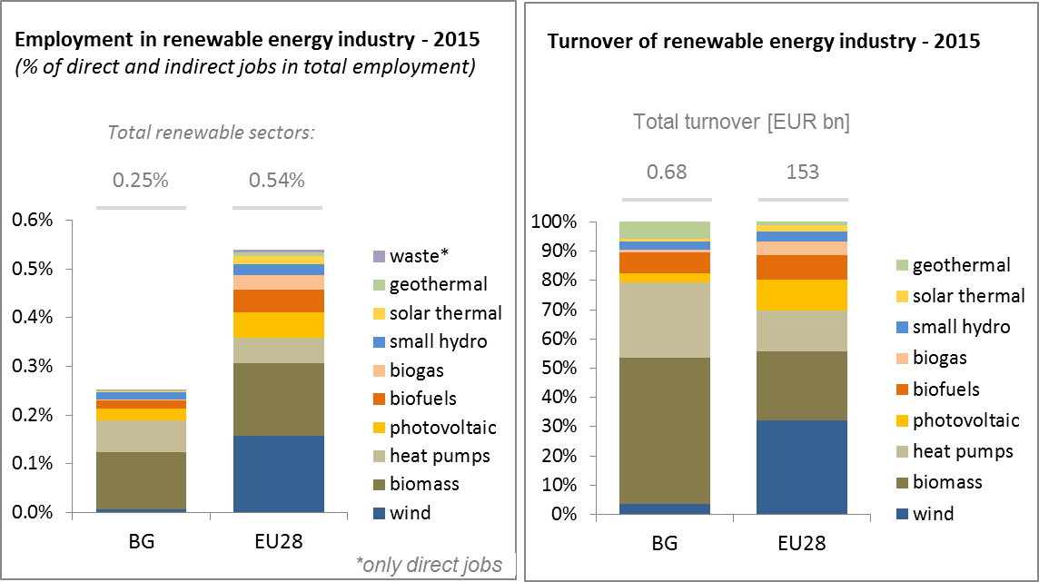

*(source: EC based on Eurobserv'Er and Eurostat)*

An indication of the level of investments in the energy sector in Bulgaria is given by the Gross fixed capital formation (GFCF)[4]. These investments in the electricity and gas sectors, which are taken as reference sectors, represented around 4% of the country's GDP in both 2012 and 2013, which is higher than in the pre-crisis period.

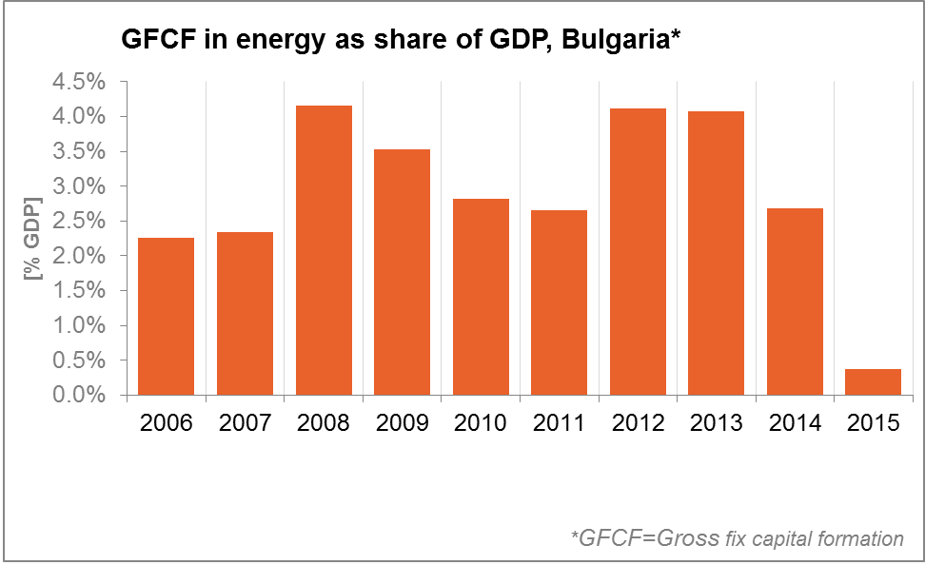

*(source: Eurostat)*

In terms of trade, Bulgaria has a deficit in fossil fuels and a surplus in electricity. In 2006 the country showed a positive trade balance in oil accounting for around 4% of GDP, whereas by 2015 it had turned into a deficit of about 2% of GDP. Similarly, trade deficit in gas increased in the same period, while the deficit in coal decreased considerably. This evolution reflects also the fall in global energy prices, which may have made imports of fossil fuels more attractive. Finally, the trade balance in electricity became positive in 2015.

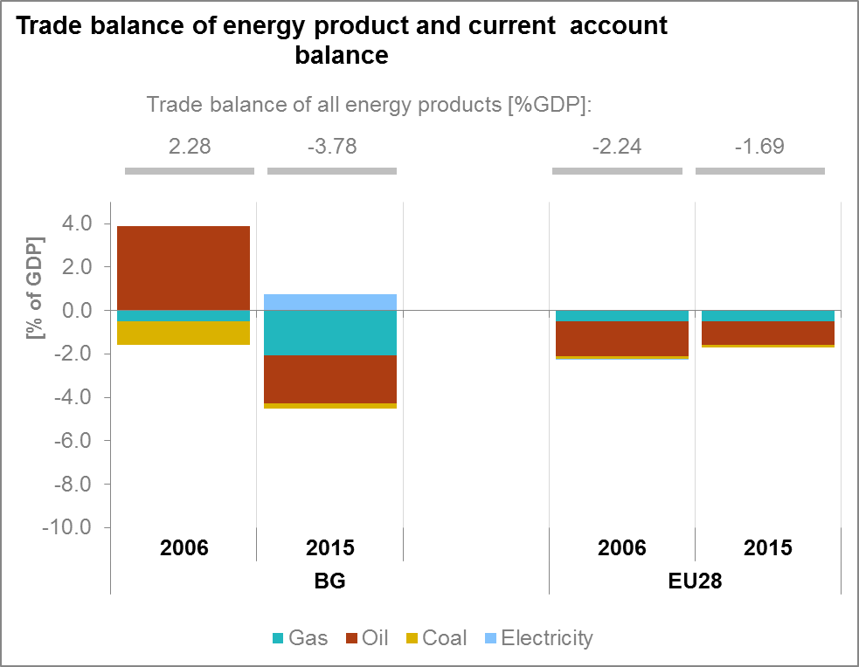

*(source: Eurostat)*

1. **Energy security, solidarity and trust**
   1. **Energy Mix**

Bulgaria's gross inland consumption of energy stood at 18.5 Mtoe in 2015, an increase of about 4% compared to the previous year but still in line with a long term trend of decreasing demand. Domestic energy production[5] increased for a second year in a row and reached 12.1 Mtoe, the second highest production value since 1990. The increase was mainly driven by lignite extraction and renewables. The country's electricity generation in 2015 reached 49.2 TWh, with strong contribution from lignite, hydro, other RES and to a lesser extent, nuclear. The 2015 level is the second highest since 1990 and represents a year-on-year increase of more than 3.5%.

Compared to the EU average, the energy mix of Bulgaria has a higher use of solid fuels (34.1% vs 16.2%) and nuclear (20.5% vs 13.6%) and lower share of petroleum and products (21.6% vs 34.5%) and gases (13.4% vs 22%) whereas the share of renewables is roughly similar (10.3% vs 12.9%).

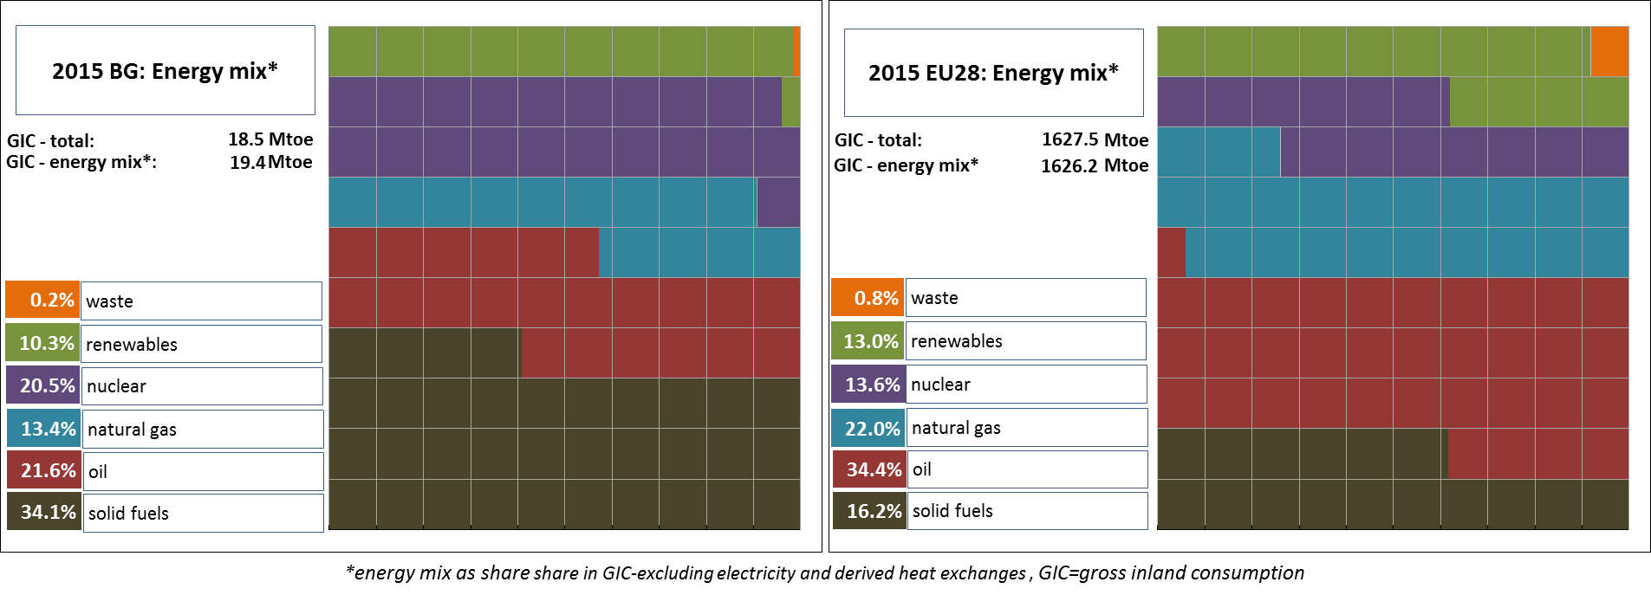

*(source: Eurostat)*

* 1. **Import dependency and security of supply**

The overall energy import dependency of Bulgaria is well below the EU average. It marked a solid improvement in the last 10 years while that of the EU increased marginally to 51.4%. From 2005 to 2015, the Bulgarian energy import dependency decreased by more than 10 p.p. and reached 35.4%, driven by a strong domestic production of lignite, a relatively high share of nuclear electricity production and by a robust expansion of renewable output.

However, Bulgaria imports almost all of its petroleum products and natural gas needed for domestic consumption. In 2015, the net import dependency of petroleum fuels, natural gas and hard coal stood respectively at 100%, 97% and 94.9%, even if uses of hard coal are relatively limited. Bulgaria purchases its gas from a single trading partner, the Russian Federation. That same partner also provided 81.2% of the crude oil and products in 2015. As a result, the supplier concentration index for gas and oil in 2015 stood at 94.2 (4th highest in the EU) and 67.1 (5nd highest in the EU) respectively.

In addition to relying on a single supplier and on a single route for its gas imports, Bulgaria has still very limited solutions for alternative supplies such as LNG and gas storage. Bulgaria is consequently vulnerable to gas disruptions.

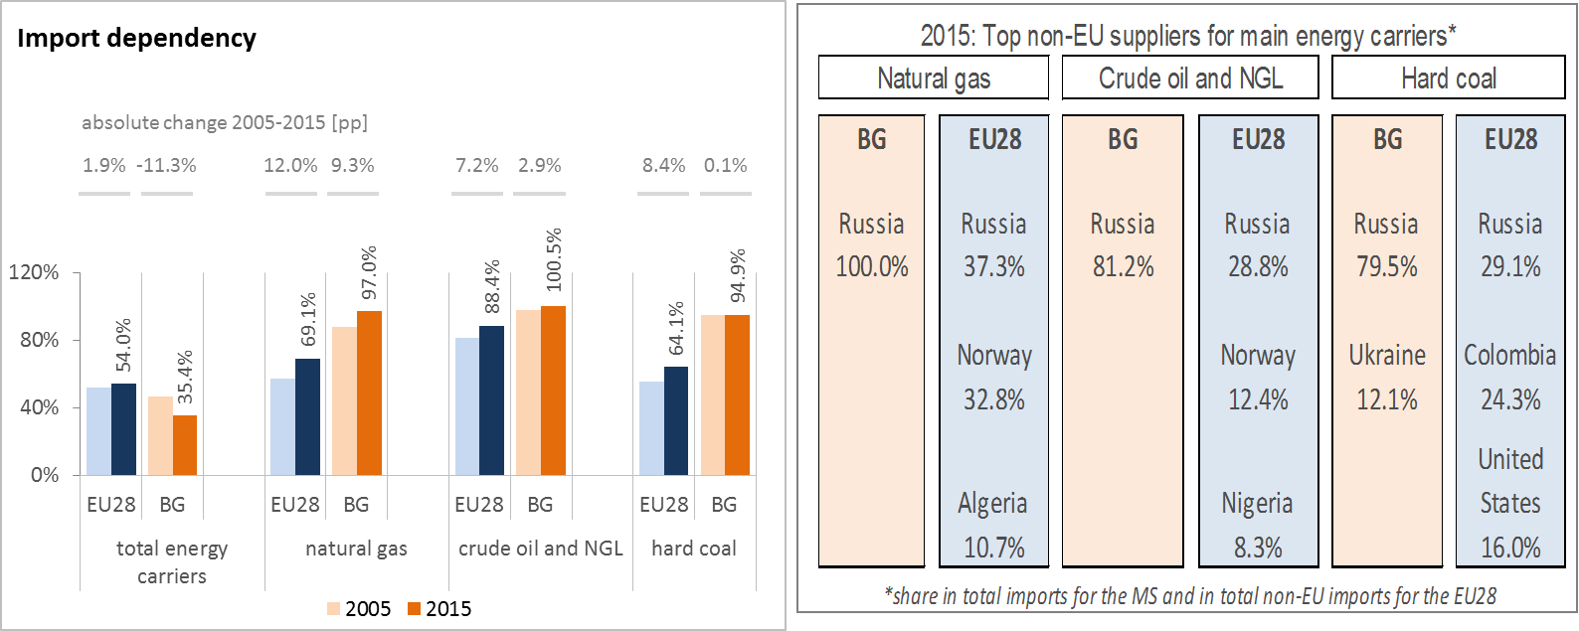

*(source: Eurostat)*

Imports of uranium and nuclear fuels are not included in Eurostat's energy balances and therefore import dependency cannot be calculated in the same way as for the main fossil fuels. Bulgaria purchases its nuclear fuel from a single supplier, the Russian Federation. In 2015, about 31.3% of the electricity generated was based on Russian nuclear fuel deliveries. This corresponds to the total amount of electricity generated from nuclear plants, 15.4 TWh in 2015.

The Regulation concerning measures to safeguard security of gas supply requires that, if the single largest gas infrastructure fails in one Member State, the capacity of the remaining infrastructure is able to satisfy total gas demand during a day of exceptionally high gas demand. Bulgaria is currently not complying with this rule, reaching just 50.6% of the required level. Bulgaria is using a combination of measures to mitigate the risks on security of gas supply. These measures are related to grid reinforcement (refurbishment of several compressor stations), new interconnectors with neighbouring systems (the new link Romania became operational in 2016) and demand-side measures that can lead to the interruption of supply to non-protected suppliers, in case of a severe crisis situation (defined as level 5-7 crisis).

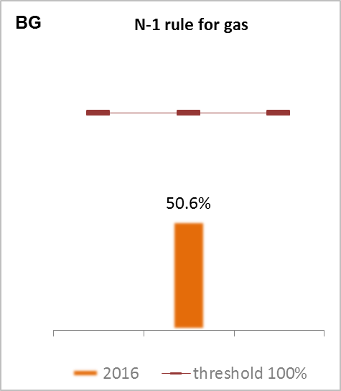

*(source: gas coordination group)*

1. **Internal market**
   1. **Interconnections and wholesale market functioning**
      1. **Electricity**

|  |  |
| --- | --- |
|  | |
| *(source: EC based on ENTSO-E scenario outlook and adequacy forecast 2014)* | *(sources: EC services based on Eurostat for the left graph and based on Platts and European power exchanges for the right graph)* |

In 2017, the electricity interconnection level[6] of Bulgaria was assessed at 7.1%, well below the 2020 target of 10%. Nevertheless, the country is on the path to reach the 10% target by 2020 through the completion of PCIs currently under way. Bulgaria participates in the TEN-E Central Eastern and South Eastern regional group for North-South electricity interconnections which can help it reach the interconnection targets.

The market concentration in the Bulgarian power generation sector is below EU average. The 2015 HHI[7] respective values for Bulgaria and EU are estimated at 3210 and 3726 respectively. The combination of a large number of sellers and a well-supplied market represent a strong strategic resource that could allow Bulgaria to play a leading role in the South Eastern electricity market. Yet those advantages are hampered by the segmentation of the wholesale market. Furthermore, the regulated segment is organised as a single buyer model with a quota system granting priority access to uncompetitive power plants. The free segment faces its own problems with market transparency and liquidity that can be further improved by setting up a strong and truly independent power exchange trading on the whole spectrum of products, from intra-day and day-ahead to year-ahead and contracts and other derivative products.

Bulgaria has recently embarked on a series of difficult, overdue reforms in the energy sector, with some tangible results including: enforcing the independence of the energy regulator through amendments of the Energy Bill; the setting up of a power exchange and steps for opening of the retail competition; the payment of arrears and restructuring of the long term purchasing agreements with some lignite power generators and the switching to market-based mechanisms for renewables support.

* + 1. **Gas**

Bulgaria is buying almost all its gas from its single supplier via the single supply route through Ukraine, the Republic of Moldova and Romania. The relatively poor trading choice is further compounded by a market structure which is dominated by a traditional incumbent company and a lack of transparency and influence on wholesale price formation.

Market concentration numbers and price levels compare very poorly to the EU average: 2015 HHI numbers for Bulgaria and the EU stood respectively at 9484 and 4771. In addition, Bulgaria is among the Member States that are still vulnerable to supply disruption.

On the positive side, Bulgaria is a member of the Central Eastern and South Eastern Gas Connectivity (CESEC) regional initiative and 3 of the 7 high priority infrastructure projects in the CESEC region relate to Bulgaria. These include the interconnector Greece-Bulgaria, the interconnector Bulgaria – Serbia and the phased reinforcement of the Bulgarian grid.

The inter-system gas link between Bulgaria and Romania is operational since 2016. Bulgaria has also reinforced several critical internal grid elements and awaits important results of seismic studies in several offshore blocks on the Black Sea.

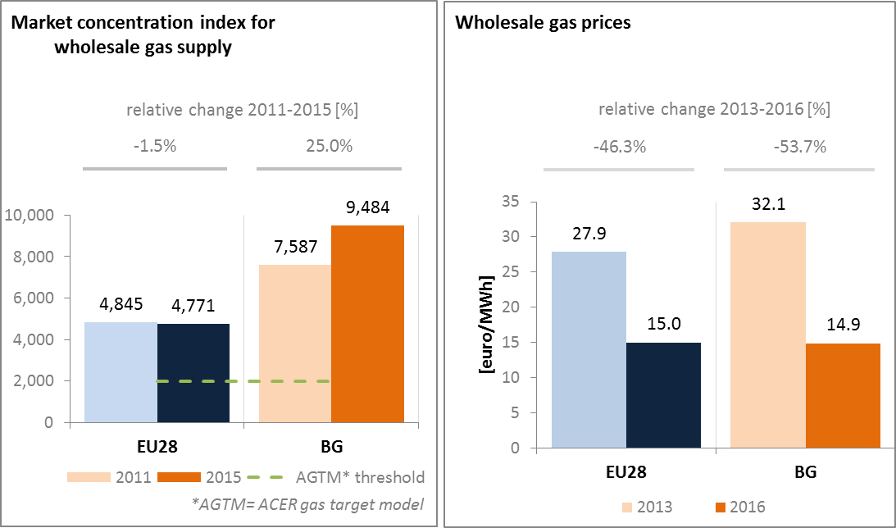

*(source: ACER for the left graph and EC services based on Platts, gas hubs, Eurostat for the right graph)*

* 1. **Retail electricity and gas markets**
     1. **Electricity**

In 2016, households' electricity prices in Bulgaria were more than twice below the EU average level, when measured in Euro per Kwh. Between 2013 and 2016, retail prices for the median consumer band for households increased by less than 1 Euro Cent / kWh, while the shares of taxes and levies remained stable. When measured in purchasing power standards per unit of energy, the Bulgarian retail prices appear much closer to the EU average, pointing to potential affordability issues for certain group of consumers (as presented in sub-section 3.3. below).

In principle, there are no restrictions for household consumers to switch suppliers but the very vast majority of them remains with the traditional, non-competitive offer of the incumbent suppliers that operate in separate, precisely defined regional markets. As a result, switching rates are negligible for household consumers and companies linked to the grid on a low voltage level.

Prices are regulated for both electricity and gas. However, Bulgaria is envisaging a progressive deregulation of all prices starting with the electricity sector.

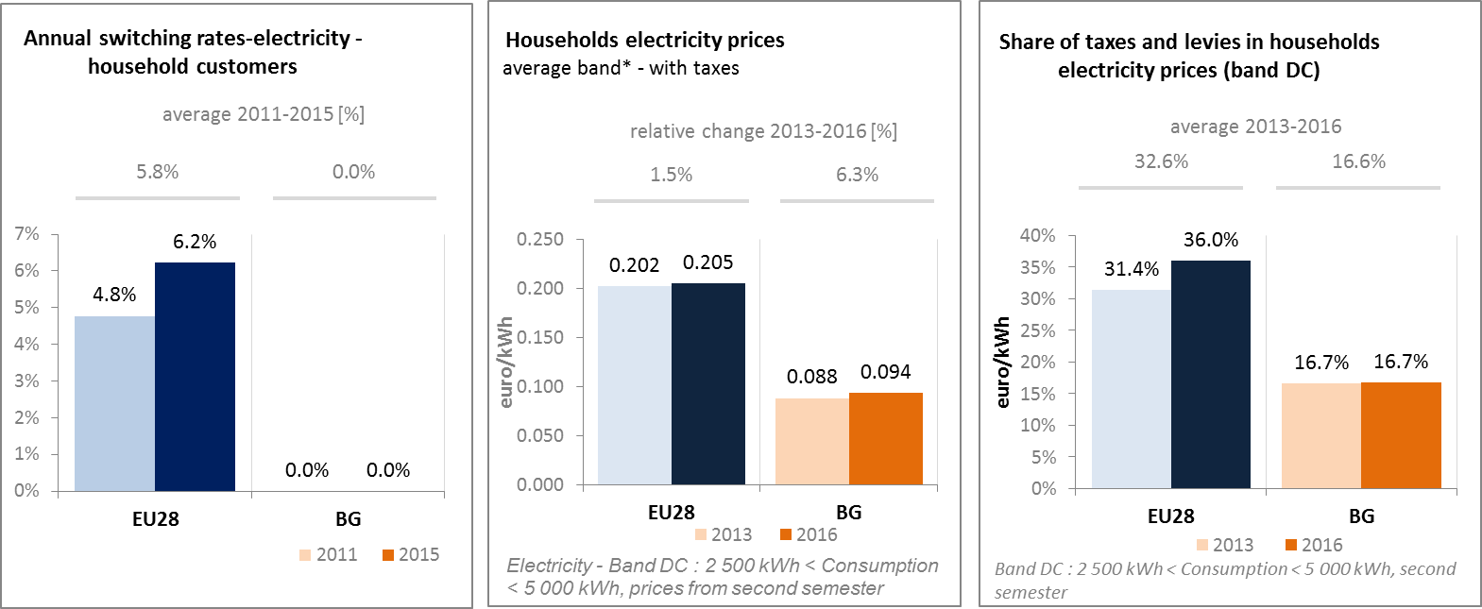

*(source: ACER) (source: Eurostat) (source: Eurostat)*

* + 1. **Gas**

In 2015 Bulgarian residential consumers used 51.8 ktoe of natural gas, representing about 2.4% of the final energy consumption of households and less than 2% of the gross inland consumption of natural gas. In 10 years the amount consumed more than tripled but the retail market is not yet fully developed, remaining confined in several urban areas with a single supplier per area. The end consumer price is regulated on a cost-plus basis.

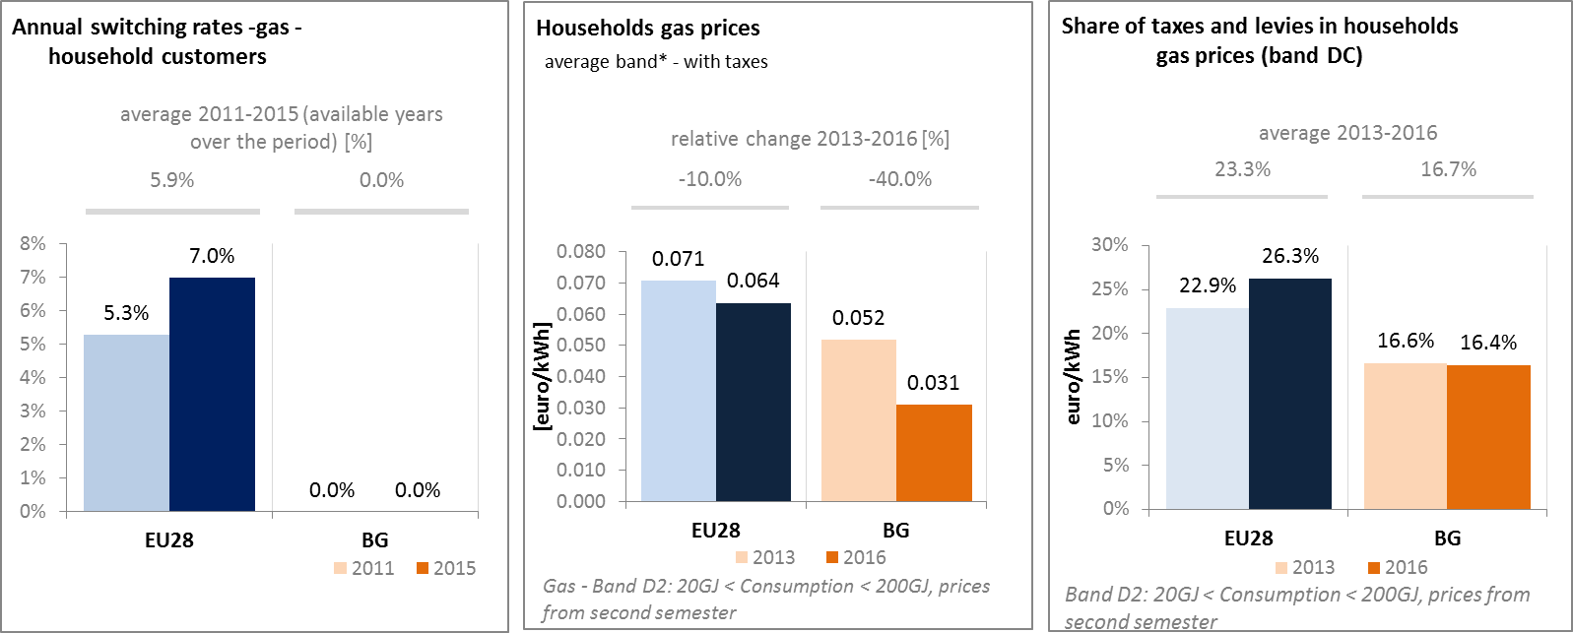

*(source: ACER) (source: Eurostat) (source: Eurostat)*

* + 1. **Market performance indicators**

Bulgarian consumers of electricity and natural gas are less satisfied than the EU average with the quality and price of services received on the energy retail markets. In addition, electricity and gas supply scores below the average of the broad sample of industries surveyed, with gas supply being the relatively better performer. The combination of low switching rates and lack of switching indicates market closure and few incentives for incumbents to improve the service.

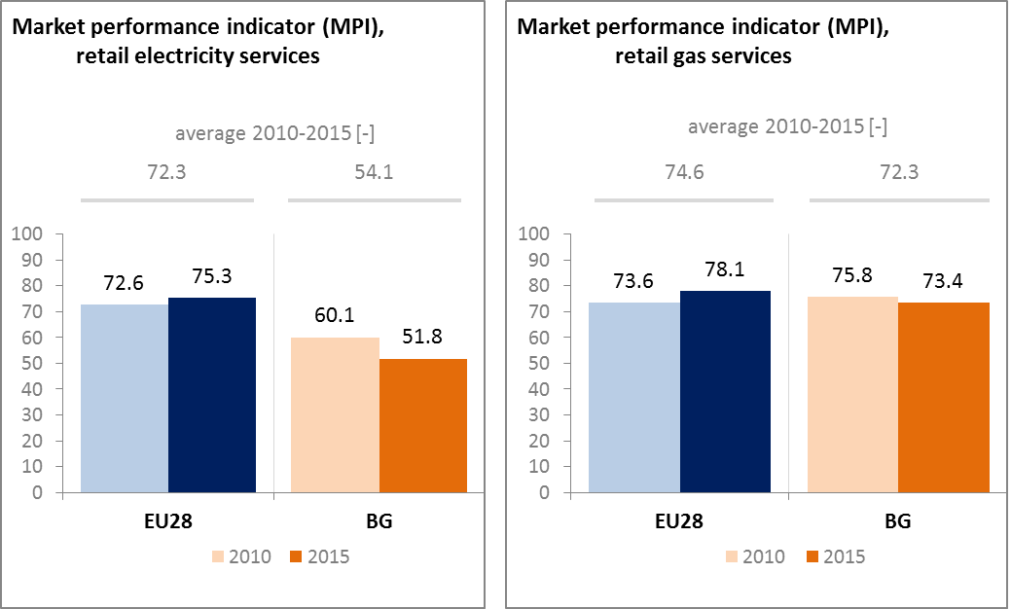

*(source: DG JUST survey)*

* 1. **Energy affordability**

In Bulgaria 20% of the poorest households spent more than 14% of their budget on domestic energy services – an increase of 3 pp over the period 2005 – 2014.

In 2015, around 67% of the most socially deprived households were still unable to keep their homes warm. This represents a decrease in comparison to 2005 when the share stood at 79%, but it remains significantly above the EU average of 23% and makes Bulgaria the worst performer in the EU on that metric.

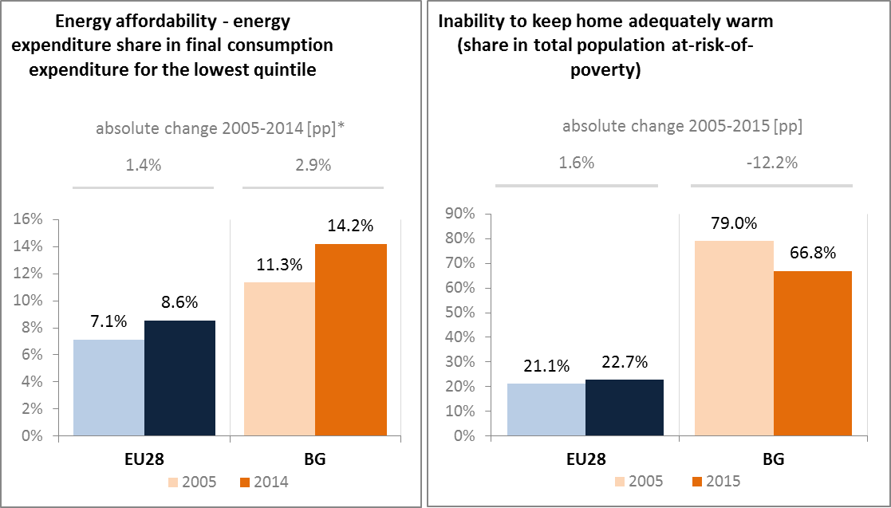

*(source: ad-hoc data collection of DG ENER based on HBS with the support of Eurostat and national statistics)*

1. **Energy efficiency and moderation of demand**

In 2015, the Bulgarian primary and final energy consumption increased for a second year in a row, reaching respectively 17.9 Mtoe and 9.5 Mtoe. Both values are about 1 Mtoe above the indicative national targets for 2020, with the road transport sector and the industry recording the biggest annual increases.

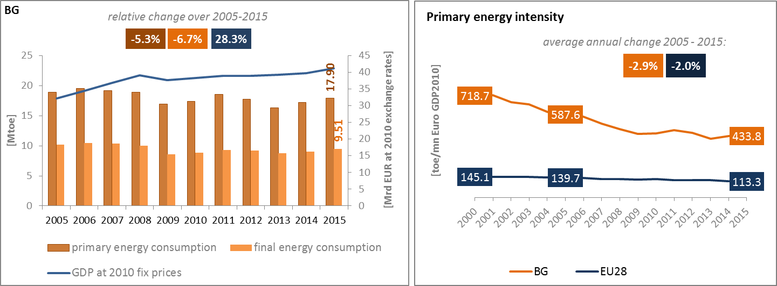

*(source: Eurostat)*

The Bulgarian primary energy intensity decreased by more than 25% over the 2005-2015 period, and by more than 39% over the last 15 years, despite a small uptick in 2015. During the same period the GDP rose by 28% (at 2010 EUR) whereas the primary energy consumption decreased by about 5%. That being said, Bulgaria remains the most energy intensive economy in the EU by a large margin.

The structure of the Bulgarian final energy consumption is quite similar to that of the EU, with industry, transport, residential, services and agriculture taking the largest shares. Compared to the EU average, the shares of industry and transport are slightly bigger in Bulgaria and those of residential and services are smaller by 2 – 3 pp.

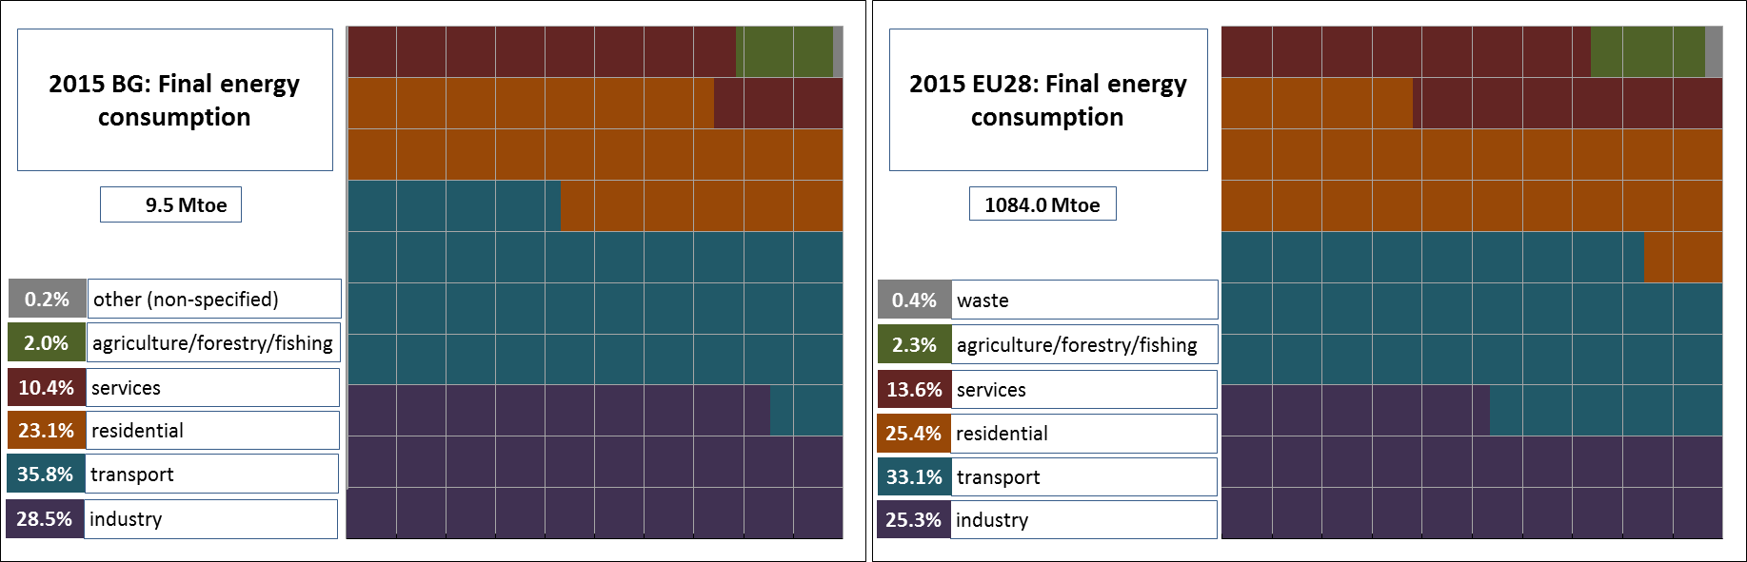

*(source: Eurostat)*

The energy intensity of the Bulgarian industry decreased significantly during the first ten years of the 21st century, starting from around 520 toe per GVA in 2000 and ending at around 270 toe per GVA, driven mainly by changes in several energy intensive sectors (iron and steel, non-ferrous metals, chemical and petrochemical, etc.). Since then it seems to have plateaued and remains in the same range.

The evolution of the industrial structure and processes used are all influencing the levels of energy intensity of the Bulgarian industry which remains the highest in the EU in 2015. This is also valid, to a lesser extent, for the energy intensity of the Bulgarian services sector (3rd highest in the EU in 2015). On the other hand, the energy intensity of Bulgarian households is well below the EU average, when measured by energy used per square metre of habitable surface (climate corrected) or by consumption per capita.

Additional efforts could therefore be envisaged to improve energy intensity in these various demand sectors. Furthermore, the implementation of the national energy efficiency actions and programs needs to be pursued in order to meet the cumulative saving requirements stemming from Article 7 of the Energy Efficiency Directive.

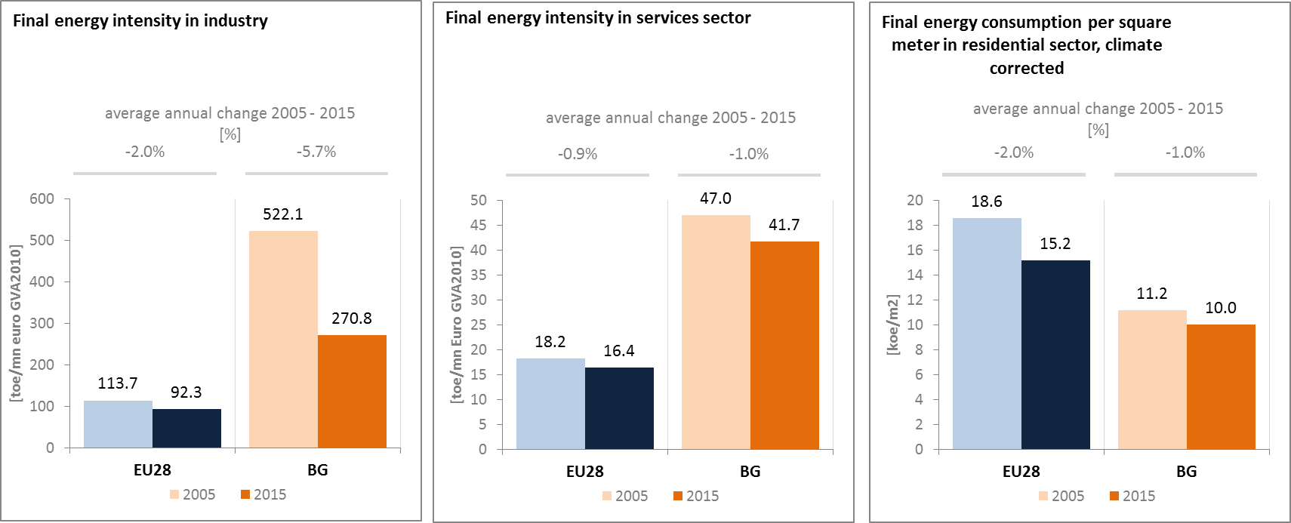

*(source: Eurostat) (source: Eurostat) (source: Odyssee database)*

Between 2005 and 2015 in Bulgaria, the final energy consumption in transport recorded an average annual increase of 1.8%, which is below the 2.6% average annual increase of the GDP. The increase of the energy consumption was accompanied by efficiency improvements, both in passengers and in freight transport vehicles. Over the period 2005 – 2015, the passenger activity (in bn passenger–km) in Bulgaria was steadily rising and increased by more than 35%. Likewise, the freight transport activity (in tonne-km) also increased more dynamically than the energy consumption in transport (21.9% vs 18.9%).

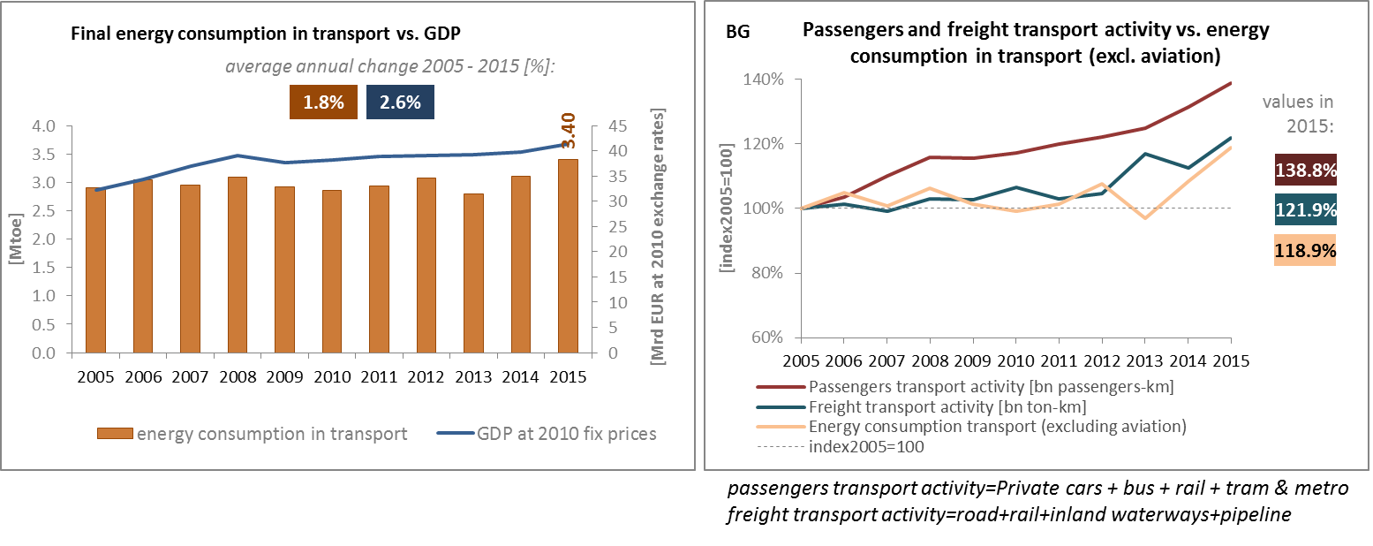

*(source: Eurostat) (source: Eurostat and DG MOVE pocketbook)*

The share of collective passengers land transport in total passengers' transport decreased significantly between 2005 and 2015 from 31.4% to 19.8%, indicating a higher use of private transport means in Bulgaria.

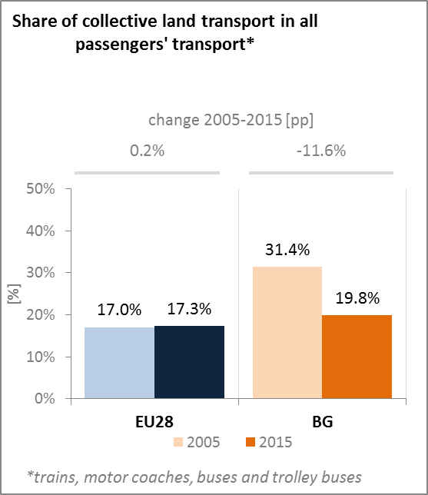

*(source: Eurostat)*

Introducing the electronic system for road toll collection, along with increased supervision over public spending with regard to road infrastructure are among the top priorities of Bulgaria's new Government, which took office in May 2017. Among the new priorities will also be the continuous use of concessions as a mechanism for developing the transport system.

Concerning the investments in transport infrastructure until 2020, the most important projects are for railways connections (from Sofia via Plovdiv to Burgas and to Svilengrad – Turkish border), with the support of the Structural Funds and also the CEF.

The Integrated transport strategy for the period until 2030 is in the final stages of preparation. Out of the 11 activities included in the scope of the strategy, 10 have been implemented so far. The last remaining activity is related to the environmental assessment of the document.

Concerning inland navigation, there are on-going discussions about improvements of the navigability of the Danube and the connections of the ports of Burgas and Varna with the hinterland. Nevertheless, several bottlenecks remain, which are hindering the navigation along the Danube section of the Rhine-Danube Core Network corridor.

1. **Decarbonisation of economy**
   1. **GHG emissions**

Based on proxy values, in 2016 GHG emissions in Bulgaria were estimated at 58.9 mtCO2eq, 43.5% below their 1990 levels. The relative decrease is almost double to that of the EU average. Based on national projections, Bulgaria will meet its 2020 emissions target with a margin of 21.7 percentage points. In 2016 emissions in the non-ETS sectors (falling under the Effort Sharing Decision) were 12.6 percentage points below the interim target for 2016.

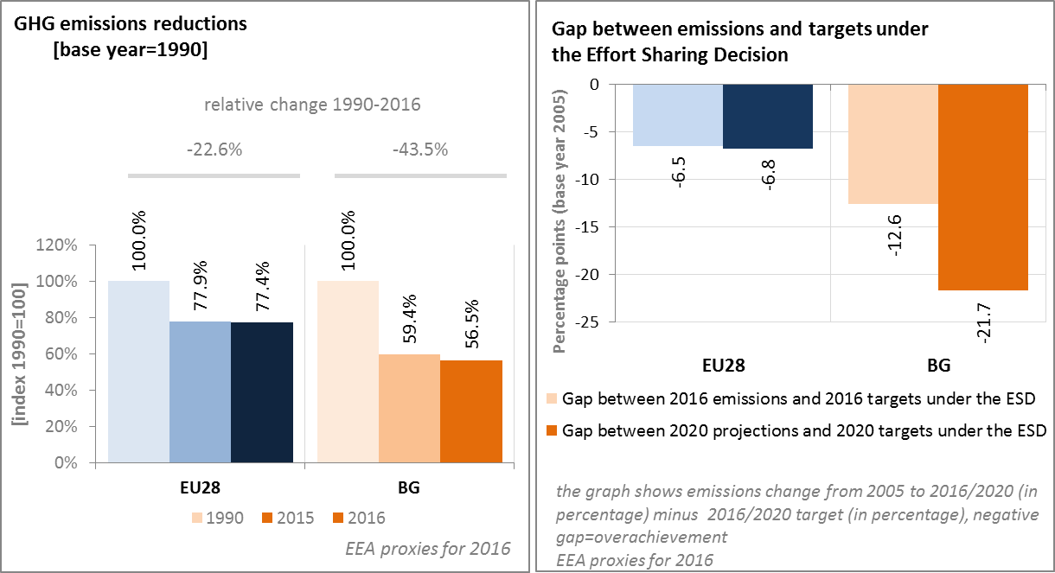

*(source: EC and EEA)*

Bulgaria remains the most GHG-intensive EU Member State. According to 2016 EEA estimates, the GHG intensity of Bulgaria's economy, measured in t CO2eq/M EUR (2010), has decreased by more than 60% compared to its level in 1990. Yet, the 2016 level is 4.3 times higher than the EU average (in 1990 it was almost 6 times higher). Since 2005, the pace of decrease of GHG intensity of the Bulgarian economy is similar to that observed in the EU.

In 2016, the GHG emissions per capita in Bulgaria remained below the EU average (8.3 kg CO2eq vs 8.7 CO2eq), in line with a tendency since 1990.

In 2015 in Bulgaria, the largest sectors in terms of GHG emissions were the energy sector (representing more than half of the total GHG emissions) followed by transport (15.2%), industry (13.9%) and agriculture (10.5%). In relative terms, the GHG emissions from residential and commercial sectors of Bulgaria were more than 5 times below the EU average (2.2% vs 12.1%).

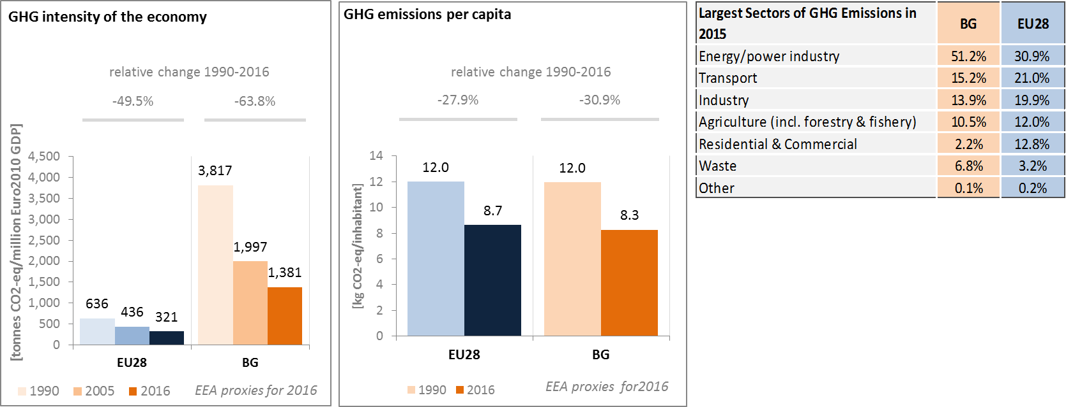

*(source: EC and EEA)*

Preliminary accounts under the Kyoto Protocol for Bulgaria show overall emissions of +1.1 Mt CO2-eq. as an annual average in the period 2013-2015. For comparison, the annual average of the EU-28 accounted for removals of -119.0 Mt CO2-eq. Bulgaria is one of four EU Member States which show overall emissions in this preliminary accounting exercise. This is primarily due to Forest Management accounts showing emissions; Bulgaria is one of only three EU Member States with this accounting issue.

Emissions by Forest Management are notably higher than removals by Afforestation with only a minor contribution of emissions by Deforestation. Overall, there is no clear trend in emissions, mainly due to varying emissions by Forest Management and Deforestation. Afforestation shows an increase in removals over the course of the three-year period.

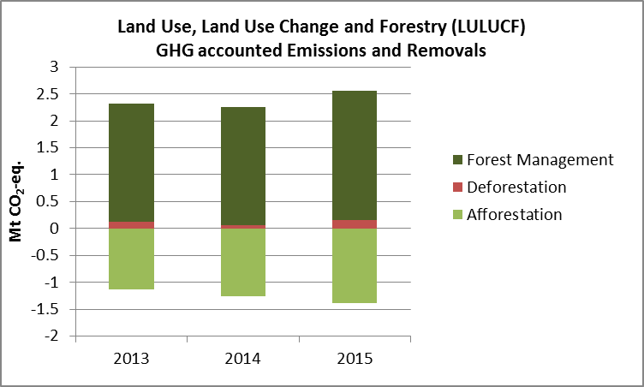

*Note: Forest Management credits are capped and presented as yearly averages when the total Forest Management credits of the considered period exceed the simulated cap over the same period.*

*(source: EC and EEA).*

**CO2 emissions in transport and alternative fuelled vehicles**

In Bulgaria, CO2 emissions from road transport were about 53% higher in 2015 than in 1990, reflecting the consistent increase of passengers and freight traffic when moving towards market economy. The average CO2 emissions of new cars in Bulgaria remained above the EU level in 2016 for a value of 126 tons gCO2/km, although decreasing by 26.7% when compared to 2005 levels.

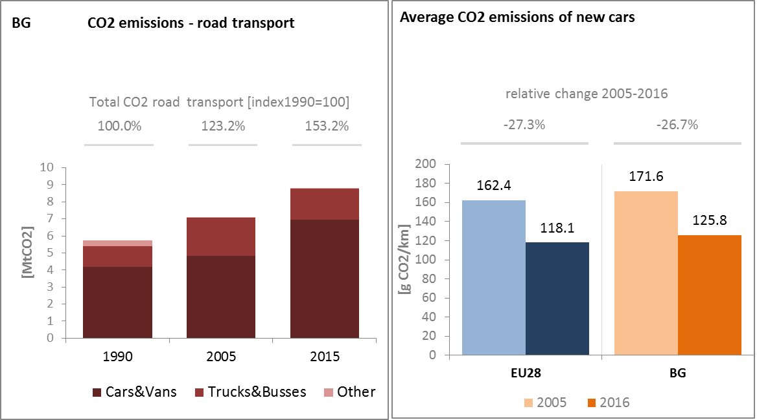

*(source: European Environment Agency/UNFCCC)*

The share of electric and hybrid-electric cars in total sales on the Bulgarian market is very small, around 0.03% of total cars sales in 2015 (i.e. merely 5 petrol-electric cars out of a total of 17 120 new cars sold in 2015). The number of electric charging points in Bulgaria is low, amounting to 22 units in 2016.

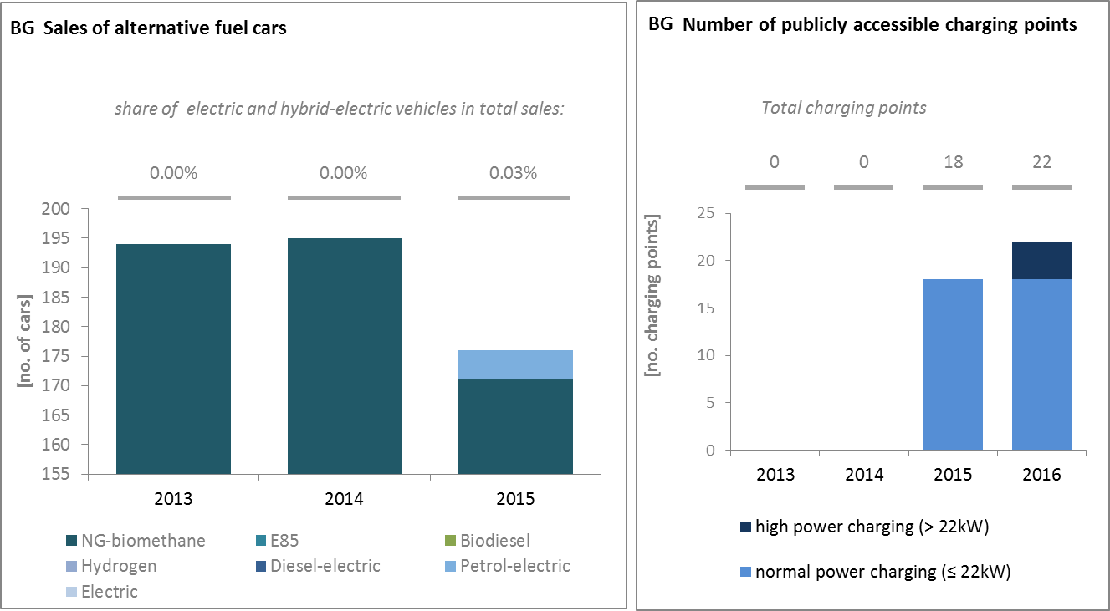

*(European Environment Agency) (European Alternative Fuels Observatory)*

National Policy Frameworks under Directive 2014/94/EU on alternative fuels infrastructure have to establish targets, objective and measures for the development of the market of alternative fuels in the transport sector and the deployment of the relevant infrastructure. Bulgaria has submitted its National Policy Framework as requested under article 3 of the Directive 2014/94/EU.

A detailed assessment of the Bulgarian National Policy Framework in terms of its compliance with the requirements of Directive 2014/94/EU on alternative fuels infrastructure, its contribution to achievement of long-term energy and climate objectives of the Union and coherence of its targets and objectives in terms of cross-border continuity has been published as part of the Communication on Alternative Fuels Action Plans (COM(2017)652) and  the related staff working document SWD(2017)365.

* 1. **Adaptation to climate change**

Bulgaria has not yet adopted its National Strategy on adaptation to climate change. In 2014 a climate change risk and vulnerability assessment for the sectors of the Bulgarian economy was finalised, which is serving as a basis for the further development of the National Adaptation Strategy, foreseen to be finalised in 2018. This framework document identifies agriculture, forestry, water, urban environment, energy, transport, construction and infrastructure, ecosystems and biodiversity, human health and tourism as key vulnerable sectors. Since no NAS has been adopted yet, a monitoring and reporting framework does not exist to this date.

* 1. **Taxes on energy and transport**

The overall tax burden on energy and transport in Bulgaria is equal to around 2.7% of GDP, which is slightly higher than the EU average due to the transport fuel component. Taxation of heat and electricity is much below the EU-average; similarly the tax burden on transport vehicles was about half of the European average in 2015. Bulgaria does not apply any carbon component in its transport fuel or vehicle tax.

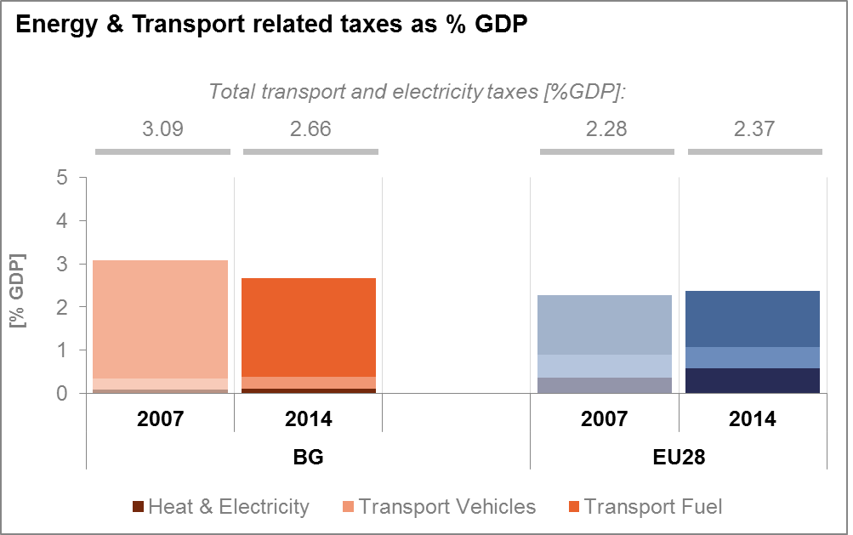

*(source: Eurostat)*

* 1. **Renewable energy**

Bulgaria is on track in attaining its renewable energy target for 2020. Bulgaria also met the 2013/2014 and 2015/2016 indicative trajectories as set under the Renewable Energy Directive The 2015 level of the renewable energy share in gross final energy consumption stands at 18.2%, well above the 16% target.

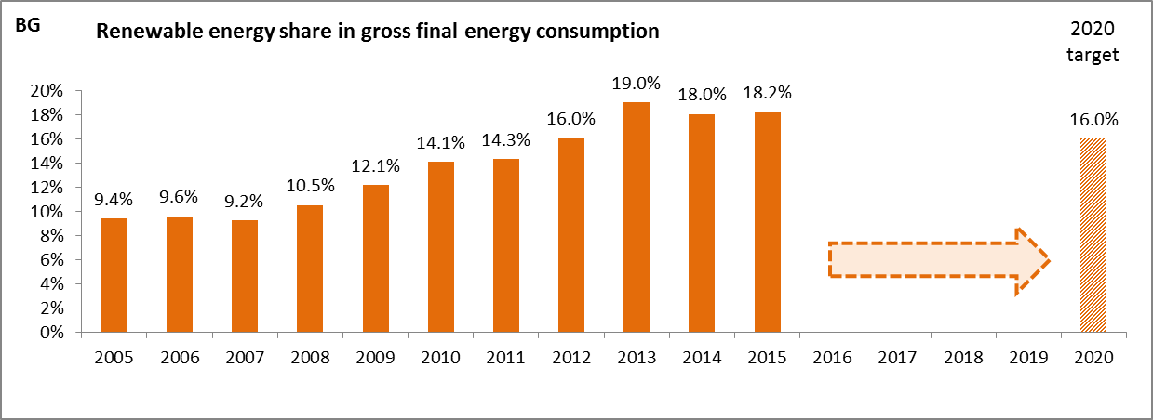

*(source: Eurostat-SHARES)*

Bulgaria's renewables share in transport stood at 6.5% in 2015, still below the 2020 target, while the renewables share in heating and cooling and the renewables share in electricity generation reached 28.6% and 19.1% respectively in 2015.

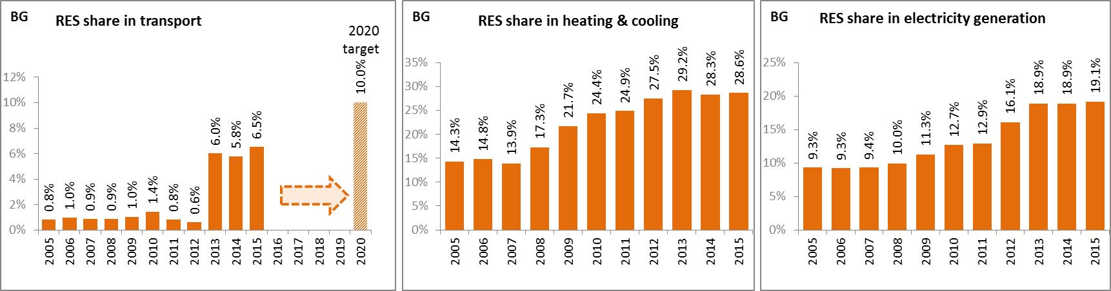

*(source: Eurostat-SHARES)*

In Bulgaria, electricity from renewable energy sources is mainly promoted through a feed-in tariff scheme. The connection of renewable energy systems to the grid is subject to the provisions of the general legislation on energy. Renewable energy is given guaranteed access to transmission and distribution networks within a period defined by the law.

Bulgaria promotes the development, installation and usage of renewables-installations through a professional training programme for renewables-installers, through a building obligation for the use of renewable heating and for the exemplary role of public authorities.

Due to a consistent deployment of renewables since 2005, it is estimated that Bulgaria avoided in 2015 about 10.3% of the fossil fuel in gross inland consumption and about 8.4% of GHG emissions at national level as compared to 2005.

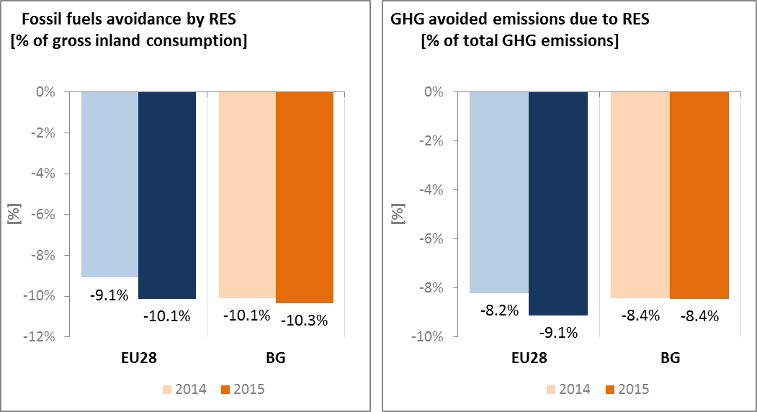

*(source: EEA)*

* 1. **Contribution of the Energy Union to better air quality**

Air quality in Bulgaria continues to give cause for severe concern. For the year 2013, the European Environment Agency estimated that about 13,700 premature deaths were attributable to fine particulate matter (PM2.5) concentrations and 570 to nitrogen dioxide (NO2) concentrations[8].

For PM, Bulgaria reported exceedances of the binding EU air quality standards[9]. For the year 2014, Bulgaria reported exceedances of the limit value for PM10 in all of the 6 air quality zones in Bulgaria, while exceedances of the limit value for PM2.5 were reported in 4 of the 6 zones[10].

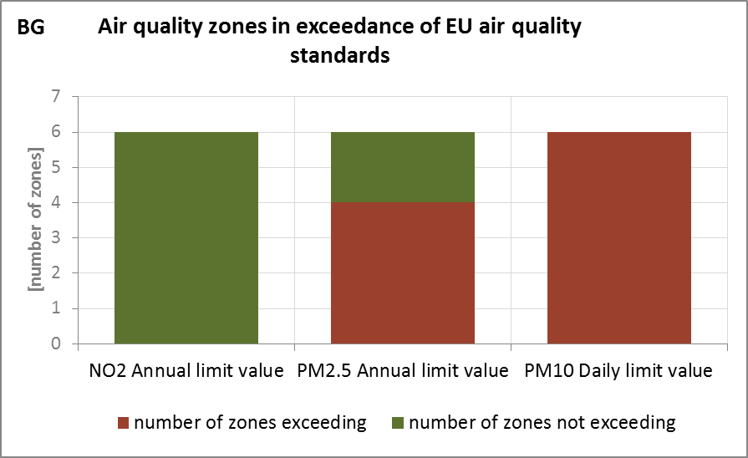

*(source: EEA)*

The health-related external costs from air pollution in Bulgaria have been estimated to be more than EUR 3 billion/year (income adjusted, 2010), which includes the intrinsic value of living a healthy life without premature death as well as the direct costs to the economy such as healthcare costs and lost working days due to sickness caused by air pollution[11].

The Energy Union can substantially contribute to addressing these air quality problems through measures reducing emissions of both GHG and air pollutants such as PM and nitrogen oxides (NOx) from major contributing sectors such as (road) transport, energy production, industry and residential heating (e.g. stoves and boilers) as shown below[12].

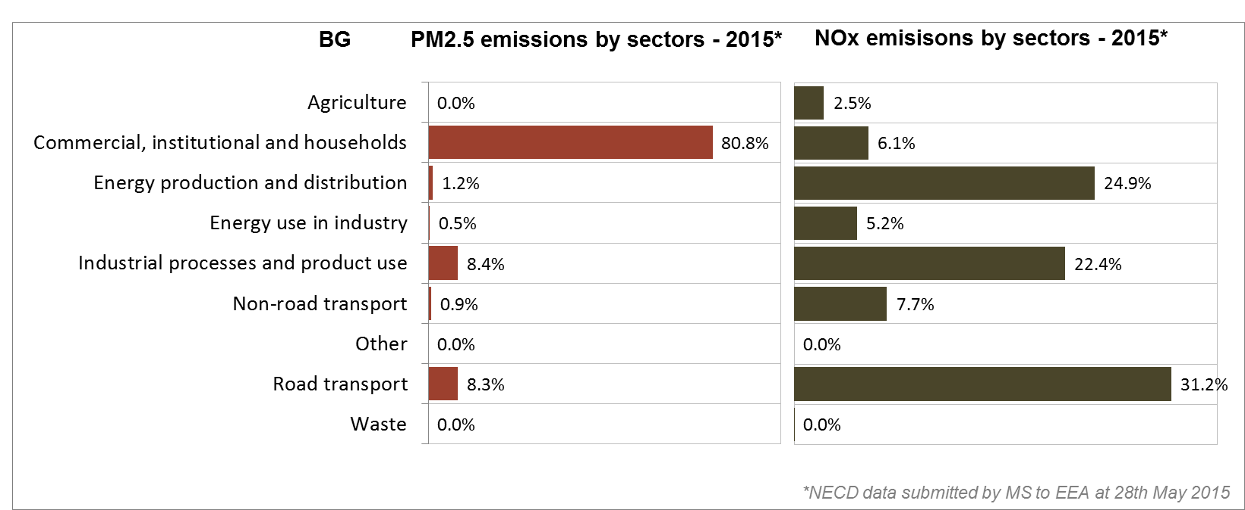

*(Source: EEA. This table reflects only sources of primary PM2,5 emissions.)*

1. **Research, innovation and competitiveness** 
   1. **Research and innovation policy**

Energy research is one of the highest priorities in Bulgaria’s National Research Development Strategy for the period 2011–2020, which sets out the national plan for investment in R&I. Investment in energy efficiency and in renewable energy innovations is also covered by the National Innovation Strategy. The National Research Development Strategy aims to stimulate R&I by industry and facilitate cooperation between R&I departments, universities and companies. It also seeks to increase financial resources for innovation by establishing mechanisms to attract private investment.

Bulgaria is not very active in the ongoing work of the Strategic Energy Technology (SET) Plan: it only participates in two (out of fourteen) temporary working groups for the implementation of the integrated SET Plan, those dedicated to energy efficiency in industry and nuclear safety.

Regarding the Horizon 2020 programme, Bulgaria has received so far 0.4% of the EU contribution devoted to the 'secure, clean and efficient energy' part of the programme. As of September 2017, 64 participations from Bulgarian organisations have been awarded EUR 7.8 million in Horizon 2020 energy projects. This includes three grants totalling over EUR 1.1 million to Bulgarian beneficiaries participating in project InDeWaG (building glazing systems), and a grant of almost EUR 0.5 million to Albena AD for its participation in project INVADE (renewable energy storage).

* 1. **Investments and patents in the Energy Union R&I priorities**

The European Commission does not have data regarding the public (national) investments in the Energy Union R&I priorities in Bulgaria.

Private investment in the Energy Union R&I priorities in 2013 was estimated at EUR 11 million (0.1% of the private R&I investment in Energy Union R&I priorities in the EU). The focus was on Nuclear Safety, which received 39% of these investments, followed by the Smart System and Sustainable Transport priorities with shares of 24 and 23%, respectively.

In 2013, the most recent year for which complete patent[13] statistics are available, 7 companies and research organisations based in Bulgaria filed 4 patents in low-carbon energy technologies (0.1% of the EU total). The focus was on the Smart System, Nuclear Safety and Sustainable Transport priorities (29% each).

In 2013, private R&I investments and patents in Energy Union R&I priorities were lower than the EU average when normalised by GDP and by population respectively. In the period 2008-2013, both private R&I investments and the number of patents in Energy Union R&I priorities have decreased on average by 17% and 14% per year, contrary to the respective EU indicators that increased at average rates of 6% and 15% respectively.

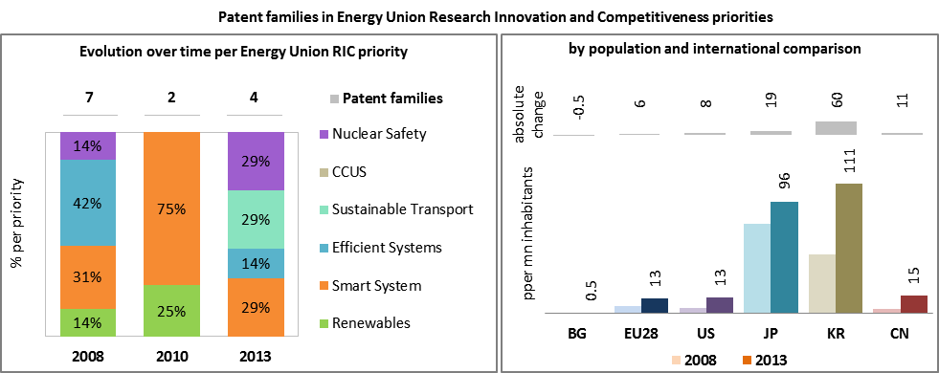

*(Data sources: Patent data based on the European Patent Office PATSTAT database[14]. Private investment as estimated by JRC SETIS. Detailed methodology available from the JRC[15].)*

* 1. **Competitiveness**

In the first half of 2016, electricity prices for industry (excluding VAT and other recoverable taxes and levies) were about a fifth lower in Bulgaria than the EU average for medium level consumers. For natural gas the Bulgarian price was about a third lower than the average for the EU. Comparing to the US, electricity prices in Bulgaria were higher by 10 to 50%, while natural gas prices were 2.5 times as much.

In 2014, real unit energy costs (RUEC)[16] of the Bulgarian economy were however more than four times bigger than the average for the EU, an indication that Bulgaria cannot exploit fully the potential of the relatively low energy prices because of the inefficient use of energy that is required to produce a unit of value added.

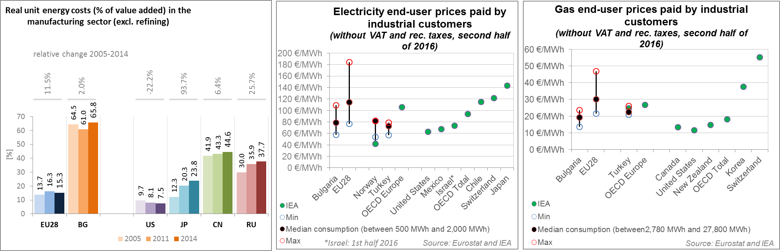

*(source: ECFIN) (source: Eurostat and IEA)*

Bulgaria is performing rather well in the wind sector. The country managed to considerably increase its specialisation in 2015 compared to 2005, as measured by the revealed comparative advantage indicator[17]. Nonetheless, the country still shows a negative relative trade balance[18], suggesting that Bulgaria is a net importer in the sector. However, the improvement in the wind exports is showing its positive effects, as indicated by the reduction in the relative trade balance in 2015. Conversely, Bulgaria is not specialised in the solar PV sector. The relative trade balance confirms the weaker position of the country in solar PV, with a negative value and below the EU average.

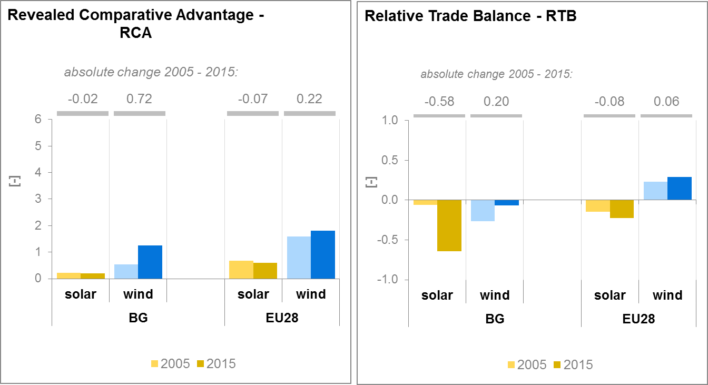

*(source: UN comtrade)*

1. **Regional and local cooperation**

Bulgaria is a member of the Central East South Europe Gas Connectivity (CESEC) High Level Group. The main aim of the group is to coordinate efforts to facilitate cross-border and trans-European projects that diversify gas supplies to the region, as well as to implement harmonised rules. Bulgaria, as a regional gas hub, has an important role there. 3 of the 7 crucial gas infrastructure projects are related to Bulgaria (interconnectors with Greece and Serbia and reinforcement of the internal grid).

In September 2016 it has been proposed that CESEC should be extended to electricity (covering issues such as electricity trading and market coupling), to coordinated planning and development of power grid infrastructures and to renewable energy and energy efficiency.

The EU macro-regional strategy for the Danube Region in which Bulgaria takes part can be used as a basis for regional cooperation on energy. European Territorial Cooperation – 'Interreg' – under EU cohesion policy also provides further opportunities for cross-border, transnational and interregional cooperation, including in the Energy Union areas.

Cities and urban areas have a key role in the energy and climate challenge. The Urban Agenda for the EU, established by the Pact of Amsterdam in May 2016, better involves cities in the design and implementation of policies, including those related to the Energy Union. It is implemented through Partnerships, in which the Commission, Member States, cities and stakeholders work together on a number of important areas, including on Energy Transition, Urban Mobility, Air Quality, Climate Adaptation and Housing. Bulgaria is participating in the partnership on Urban Mobility, with the city of Burgas as member.

By 2016 on Covenant of Mayors, 23 sustainable energy action plans have been delivered by Bulgarian municipalities. Overall, these municipalities cover about 2.25 million inhabitants representing around a third of the total population of Bulgaria. All together, these municipalities committed to reduce by 2020 the GHG emissions by 23.8% (as compared to 1990 baseline).

*Average GHG emission per capita in Covenant Baseline Emission Inventories and corresponding estimates by 2020 (source: JRC)*

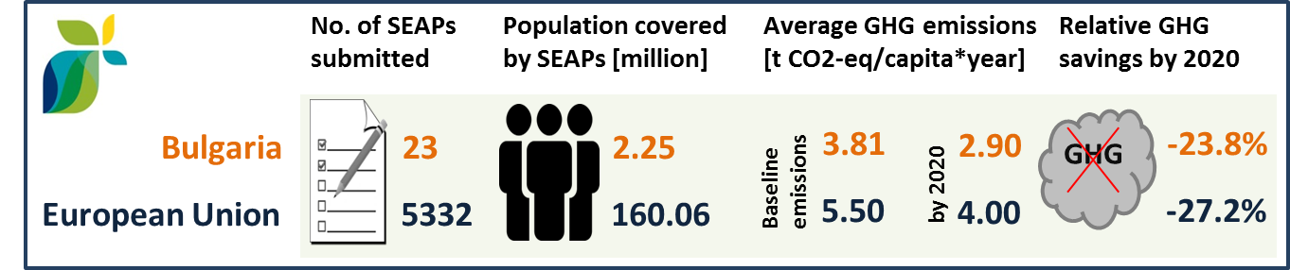

In Bulgaria, by September 2016, 2 cities (covering 0.27 million inhabitants) have committed to conduct a vulnerability and risk assessment and develop and implement adaptation plans in the framework of the Covenant of Mayors for Climate and Energy.

1. **Cohesion policy and EU clean energy investments**

EU cohesion policy makes a key contribution to delivering the Energy Union objectives on the ground, including important investment possibilities to implement energy policy objectives in Bulgaria which are complemented by national public and private co-financing, aiming at optimal leverage. It also ensures integrated territorial solutions to energy and climate challenges, supports capacity building and provides technical assistance.

Over 2014-2020, cohesion policy is investing some EUR 510 million in energy efficiency improvements in public and residential buildings and in SMEs, as well as in smart energy infrastructure in Bulgaria. Cohesion policy is also investing significantly in R&I and in SME competitiveness in Bulgaria, based on the national strategies for smart specialisation and for SMEs. For Bulgaria, the smart specialisation includes a focus on assisting clean technologies, including energy preservation and eco-mobility. At this stage, at least EUR 58 million is foreseen for investments in R&I and adoption of low-carbon technologies in Bulgaria, but this might increase further in line with the evolving content of the smart specialisation strategy. A further estimated EUR 1,174 million is invested in supporting the move towards an energy-efficient, decarbonised transport sector.

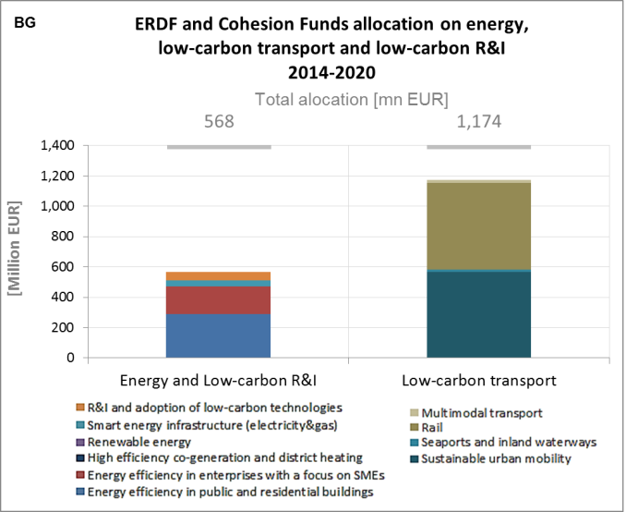

*(source: DG REGIO)*

These investments are expected to contribute to around 13 000 households with improved energy consumption classification and a decrease of around 140,645,000 kWh per year of primary energy consumption of public buildings, as well as to around 190 km of reconstructed or upgraded railway lines. Overall, the EU Cohesion policy investments in Bulgaria over 2014-2020 are expected to contribute to an estimated annual decrease of GHG emissions of around 198,000 tonnes of CO2eq.

For example, one of the most important infrastructure projects in Bulgaria in recent history, the Sofia Metro, was co-financed by the European Regional Development Fund (ERDF) in 2007-2013 with some EUR 500 million for the completion of its first two lines. Serving 50,000 people hourly, it is used by over half a million people every day. It has had enormous benefits for the population of Bulgaria’s capital: from dramatic reduction in CO2 emissions, travel times, traffic jams (by over 20%), traffic accidents, fuel consumption and transport maintenance costs, to generating savings for the local economy of over EUR 20 million. In 2014-2020, European Structural and Investment Funds will invest EUR 520 million for an additional 16 km of lines and 19 metro stations, thus bringing the total Sofia subway network to 56 km of lines and 53 stations by 2020.

As another example, preparatory activities under the project for the construction of the section on Bulgarian territory of the gas interconnector between Bulgaria and Serbia were co-financed by the European Regional Development Fund (ERDF) in 2007-2013. The planned EUR 38 million of ERDF investment in 2014-2020 is expected to increase security of supply, support the main priorities of the Energy Strategy of Republic of Bulgaria till 2020 and meet the EU N-1 infrastructure standard.

Through its support to sustainable transport systems, the Connecting Europe Facility (CEF) also contributes to the goals of the Energy Union. Following Bulgarian participation in the CEF – Transport 2014-2015 Calls, the Bulgarian action portfolio comprises 9 signed grant agreements, allocating EUR 294.4 million of actual CEF Transport Funding to Bulgarian beneficiaries (state-of-play February 2017)[19]. The transport mode which receives the highest share of funding is rail (97% of actual funding). The main focus of the Bulgarian CEF actions is the Orient/East Mediterranean corridor railway line Sofia – Plovdiv, an important element of the Trans-European Transport Core network corridors. The objective is to remove bottlenecks for the requirements for passenger and freight transport users and operators in terms of travel time, interoperability, safety and security. Bulgaria is also involved in a multi-beneficiary action dedicated to the deployment of the European Railway Transport Management System (ERTMS). Bulgaria is also active in the inland waterway (IWW) transport with some actions related to the Romanian-Bulgarian common section of the Danube. The actions aim to remove existing bottlenecks and to identify the works to achieve a good navigation status all year round.[20]

1. The indicators used in this country factsheet largely build on indicators developed for the Commission Staff Working Document "Monitoring progress towards the Energy Union objectives – key indicators" (SWD(2017) 32 final) <https://ec.europa.eu/commission/sites/beta-political/files/swd-energy-union-key-indicators_en.pdf>
2. Gross value added and employment in NACE sectors D-Electricity, gas, steam and air conditioning supply and H-Transportation and storage
3. National accounts, Eurostat
4. Gross fixed capital formation consists of resident producers´ acquisitions, less disposals, of fixed tangible or intangible assets. This covers, in particular, machinery and equipment, vehicles, dwellings and other buildings. It also includes foreign direct investment (FDI). Steam and air conditioning supply are also included in the figures mentioned above as Eurostat reports electricity, gas, steam and air conditioning supply together.
5. Primary production, recycled and recovered products
6. The interconnectivity level is calculated as a ratio between import interconnection and net generation capacities of the country (i.e. the 2017 value is the ratio between simultaneous import interconnection capacity [GW] and net generating capacity [GW] in the country at 11 January 2017, 19:00 pm as resulted from ENTSO-E Winter Outlook 2016/2017)
7. HHI stands for "Herfindahl-Hirschman Index", a measure of market concentration.
8. European Environment Agency, 2016, [Air Quality in Europe – 2016 Report](https://www.eea.europa.eu/publications/air-quality-in-europe-2016), table 10.2. The report also includes details as regards the underpinning methodology for calculating premature deaths.
9. Directive 2008/50/EC of the European Parliament and of the Council of 21 May 2008 on ambient air quality and cleaner air for Europe, OJ L 152, 11.6.2008, p.1-44
10. Compliance data as reported by the Member States as part of their official annual air quality report for the calendar year 2015 (available on the European Environment Agency's (EEA) Eionet/Central Data Repository), <http://cdr.eionet.europa.eu/bg/eu/aqd>
11. See also the EU Environmental Implementation Review Country Report for Bulgaria, SWD(2017)35 final of 3.2.2017
12. National emission data as reported by the Member States to the EEA (available on the EEA's Eionet/Central Data Repository), <http://cdr.eionet.europa.eu/bg/eu/nec_revised>
13. In the context of this document, the term 'patent' refers to patent families, rather than applications, as a measure of innovative activity. Patent families include all documents relevant to a distinct invention (e.g. applications to multiple authorities), thus preventing multiple counting. A fraction of the family is allocated to each applicant and relevant technology.
14. <https://www.epo.org/searching-for-patents/business/patstat.html#tab1>
15. <https://setis.ec.europa.eu/related-jrc-activities/jrc-setis-reports/monitoring-ri-low-carbon-energy-technologies>
16. This indicator measures the amount of money spent on energy sources needed to obtain one unit of value added.
17. The RCA index for product "i" is defined as follows: ${RCA}_{i}=\frac{\frac{X_{j,i}}{\sum_{i}{X_{j,i}}}}{\frac{X_{w,i}}{\sum_{i}{X_{w,i}}}}$ where $X$ is the value of exports, and j is the country and w is the reference group, the World economy. 2005 refers in the text to the indicator average over the 2000-2009 period, while 2015 represents the average over the 2010-2016 period. The same applies for the RTB indicator - see below.
18. The RTB indicator for product "i" is defined as follows: ${RTB}_{i}=\frac{X_{i}-M_{i}}{X_{i}+M_{i}}$ where $X_{i}$ is the value of product's "i" exports and $M_{i}$ imports.
19. Note that European Economic Interest Groups and International Organisations are excluded from the analysis.
20. Source: INEA